Docker Task
Task Description:
Install docker on EC2 and explore the docker commands (docker images, containers,
EC2 created for public IP
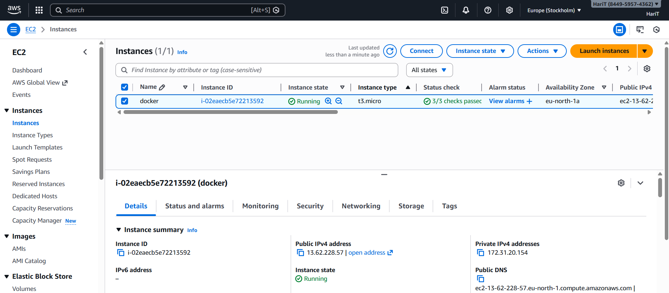

Docker checks in Ubuntu
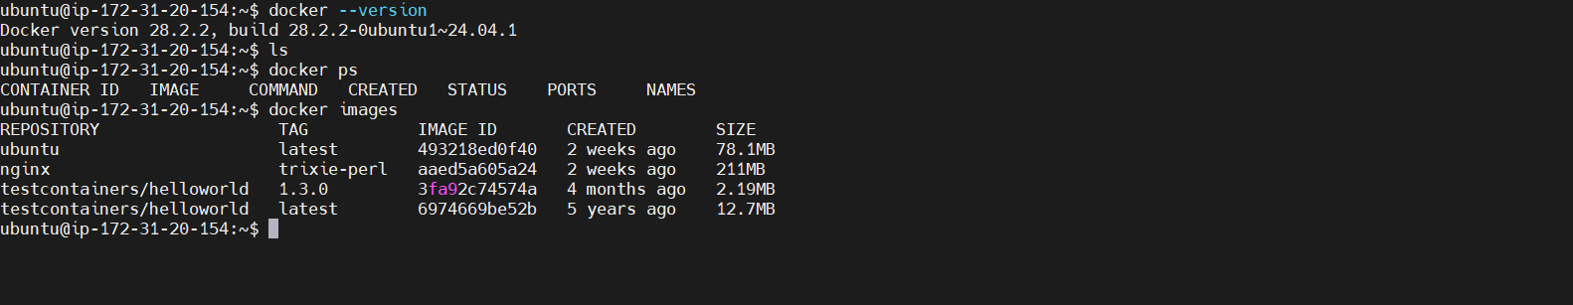

Docker commands
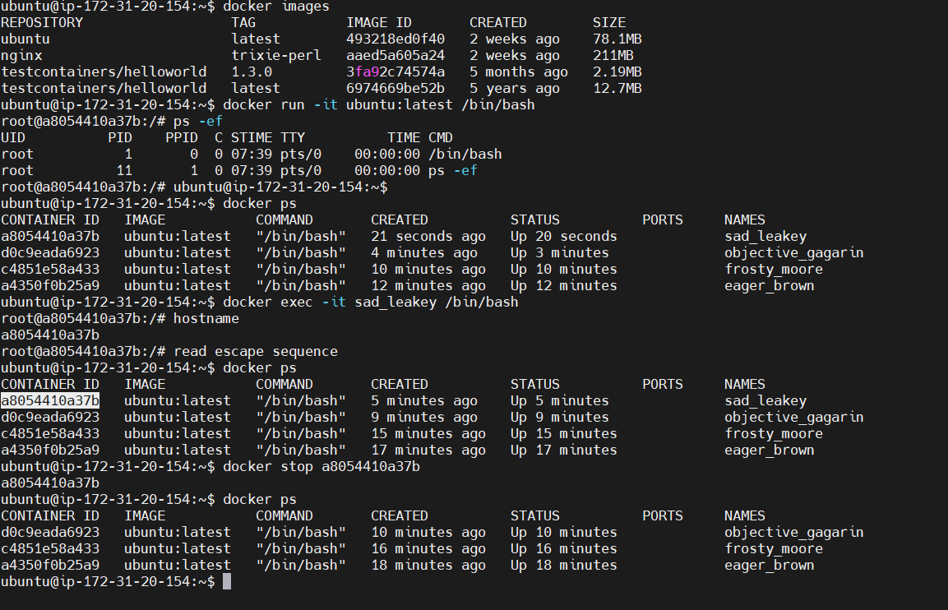
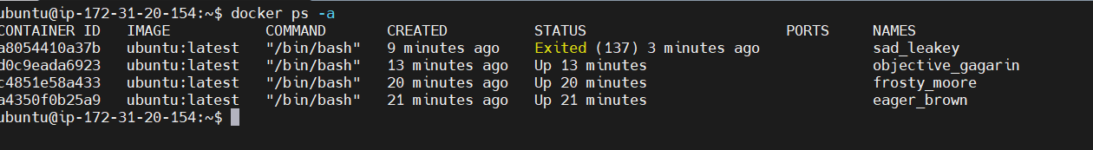
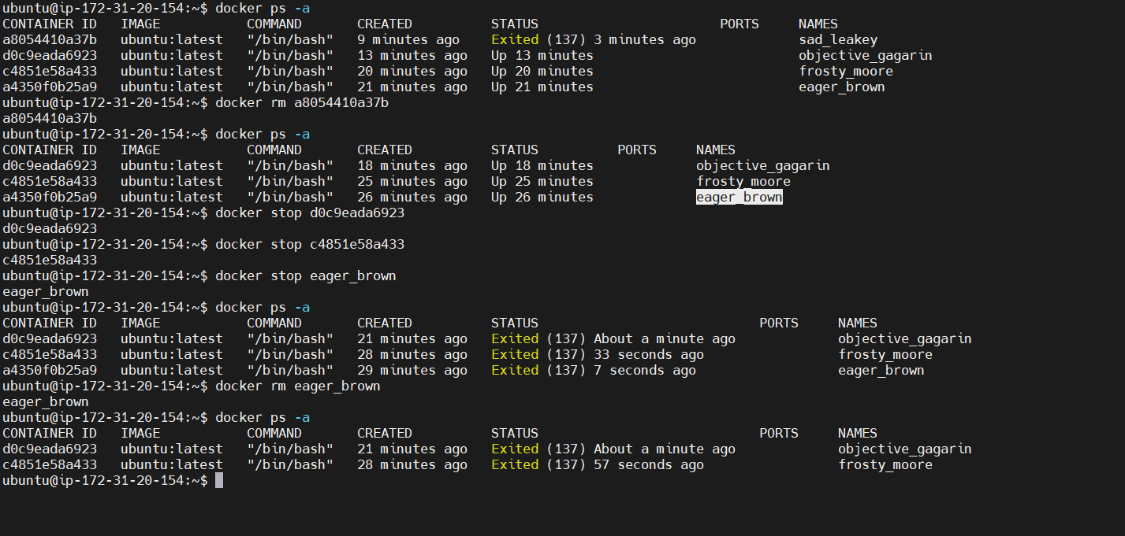

Docker image removed and pulled again
